SQL vs NoSQL Databases and Features of MongoDB

A database is an organized collection of data that can be easily accessed, managed, and updated. Databases are crucial in software applications for storing user data, application configurations, logs, transactions, and more.  
  
Two Main Types of Databases:  
1. SQL Databases (Relational Databases)  
2. NoSQL Databases (Non-Relational or Not Only SQL)

## SQL Databases (Relational)

SQL databases are structured and store data in tables, with rows and columns.  
  
Examples: MySQL, PostgreSQL, Oracle DB, Microsoft SQL Server  
Language Used: Structured Query Language (SQL)  
  
Features:  
- ACID compliance: Ensures data integrity through Atomicity, Consistency, Isolation, and Durability.  
- Predefined Schema: Data must fit a structured schema.  
- Relational Integrity: Supports foreign keys and joins.

## NoSQL Databases (Non-relational)

NoSQL databases use flexible formats to store data, such as JSON, key-value pairs, graphs, or wide-columns.  
  
Examples: MongoDB, Cassandra, Redis, CouchDB, Neo4j  
Language Used: Varies, often JSON-like queries or APIs.  
  
Features:  
- Flexible Schema: No need to predefine structure.  
- Scalable: Designed for horizontal scalability.  
- High Performance: Optimized for large volumes of unstructured data.

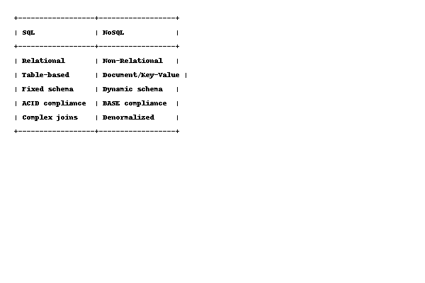

**When to Use SQL vs NoSQL**

Use SQL When:  
- Your application needs complex queries and transactions.  
- You have structured data and clear relationships.  
- Your system relies on data integrity and concurrency.  
  
Examples: Banking systems, ERP software, customer relationship management (CRM).  
  
Use NoSQL When:  
- You handle large amounts of unstructured or semi-structured data.  
- You need fast, scalable solutions with minimal downtime.  
- Your schema changes frequently or is not rigid.  
  
Examples: Real-time analytics, IoT apps, content management, recommendation systems.

**MongoDB**

MongoDB is a popular open-source NoSQL document database designed for scalability and high performance.  
  
- Data Format: BSON (Binary JSON)  
- Storage: Collections and Documents (not tables and rows)  
- Querying: JSON-like syntax 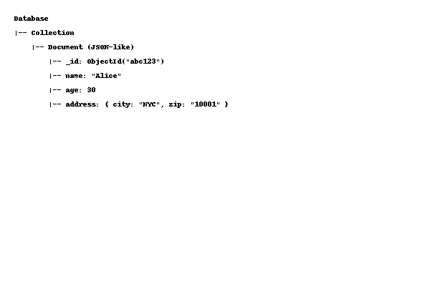

## Key Features of MongoDB

1. Document-Oriented: Stores data as documents (similar to JSON objects). Easier to map with modern programming objects.  
2. Schema-Less: Documents in the same collection can have different fields. Allows for rapid iterations and agile development.  
3. Horizontal Scalability: Supports sharding to distribute data across multiple machines.  
4. High Availability: Replica sets provide automatic failover and redundancy.  
5. Powerful Query Language: Rich and expressive queries with filters, projections, and aggregation.  
6. Indexing: Supports compound and multi-key indexes for performance.

**MongoDB Advanced Features and Use Cases**

## 1. Aggregation Framework

Used for data processing and analytics. Comparable to SQL GROUP BY.  
  
Example Pipeline:  
[  
 { "$match": { "status": "active" }},  
 { "$group": { "_id": "$city", "total": { "$sum": 1 } }}  
]

## 2. Geospatial Queries

Find data based on geographical location.  
  
Example:  
{ "location": { "$near": [40.7128, -74.0060] } }

## 3. Replication

Maintains multiple copies of data for fault tolerance.  


## 4. Shardin

Splits large datasets across multiple servers.  
  


## MongoDB Use Cases

- Real-time analytics dashboards  
- Content management systems (CMS)  
- IoT applications  
- Product catalogs  
- Mobile backends